## TOPICAL QUESTIONS FOR P.7 TERM 1 2024

### SCIENCE NO. 1

#### TOPIC: MUSCULAR – SKELETAL SYSTEM

1. What is a skeleton?

……………………………………………………………………………………………………………………………….…………………………………

1. State anyone function of the human skeleton.

……………………………………………………………………………………………………………………………………………………………………

1. Write down anyone type of skeleton.

……………………………………………………………………………………………………………………….…………………………………………

1. State the most essential mineral salts needed for proper growth and development of bones and teeth.

…………………………………………………………………………………………………………………………………………………………………

1. Explain the importance of the cartilage structure found in the outer ear of most mammals?

……………………………………………………………………………………………………………..…………………………………………………..

1. Name anyone main part of the human body.

………………………………………………………………………………………………………………….………………………………………………

1. Which delicate body organ is protected by the cranium?

…………………………………………………………………………………………………………………………..……………………………………..

1. Give one value of the skeletal system to the circulatory system.

………………………………………………………………………………………………………………..………………………………………………..

1. How does ball and socket differ from hinge joint in terms of movement?

………………………………………………………………………………………………………….………………………………………………........

......................................................................................................................................................................

1. How are muscles connected to bones in the body?

………………………………………………………………………………………………………………………………………………………………….

1. State the value of the ligament at a joint?

…………………………………………………………………………………………….…………………………………………………………………….

1. Name any two types of joints in the human body.

i) ……………………………………………………………………………………..…………………………………………………………………

ii) ………………………………………………………………………………………………………………………………………………………..

1. State the value of synovial fluid at a joint.

……………………………………………………………………………………………………………………………………………………………….

1. Give anyone example of a voluntary muscle in the human body.

………………………………………………………………………………………………….…………………………………………………………….

1. What are voluntary muscles?

……………………………………………………………………………..…………………………………………………………………………………

………………………………………………………………………………………………………………………………………………………………..

1. State the value of good posture to an individual.

…………………………………………………………………………………………………………………………………………………………………

1. Write down any two diseases which affect the skeletal system.

i) …………………………………………………………………………………….…………………………………………………………………

ii) ………………………………………………………………………………………………………………………………………………………

1. Name the deficiency disease which affects the skeletal system.

……………………………………………………………………………………………………………………………………………………………….

1. Write down any four disorders of the skeletal system

i) ……………………………………………………………………………………………………………………………………………………..

ii) …………………………………………………………….……………………………………………………………………………………….

iii) ……………………………………………………………………………………………………………………………………………………..

iv) ……………………………………………………………………………………………………………………………………………………..

1. Which part of the skeletal system protects;
   1. The heart and the lungs

………………………………………………………………………..…………………………………………………………………………….

* 1. The brain

………………………………………………………………………………………………………………………………………………………

* 1. The spinal cord

………………………………………………………………….…………………………………………………………………………………..

* 1. The reproductive organs

………………………………………………………………………………..……………………………………………………………………..

1. What is dislocation?

…………………………………………………………………………………………………………………………………………………………………

………………………………………………………………………………………………………………………………………………………………..

1. What is a fracture?

………………………………………………………………………………………………..……………………………………………………………….

1. Name one activity that can maintain the healthy conditions of the skeletal system?

…………………………………………………………………………………………..…………………………………………………………………….

1. Name any two short bones from which red blood cells are made?

i) …………………………………………………………………….………………………………………………………………………………….

ii) ………………………………………………………………………………………………………………………………………………………….

1. Identify one water borne disease of the skeletal system.

…………………………………………………………………………………….……………………………………………………………………………..

1. The diagram below shows the human arm, use it to answer the questions that follow

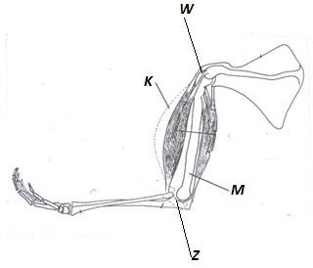

1. Name the parts marked K and M

K …………………………………………………… M: ……………………………………………………..

1. Name the kind of movement possible at W and Z

W: ……………………………………………………………………………………………………………………………………………………….

Z: …………………………………………………………………………………….…………………………………………………………………..

#### TOPIC: ELECTRICITY AND MAGNETISM

1. What is matter?

…………………………………………………………………………………………………………..………………………………………………………

……………………………………………………………………………………………………………………………………………………………………

1. What is matter made up of?

…………………………………………………………………………………………………………………………………………………………………..

1. How does mass differ from volume?

…………………………………………………………………………………………………………………………….……………………………………

………………………………………………………………………………………………………..………………………………………………………..

1. Give anyone advantage of using electricity for cooking.

…………………………………………………………………………………………………………………………………………………………………

………………………………………………………………………………………………..………………………………………………………………..

1. What is the function of a fuse in an electric circuit?

……………………………………………………………………………………...…………………………………………………………………………..

1. How does a fuse work?

…………………………………………………………………………………………..………………………………………………………………………

…………………………………………………………………………………………………………………………………………………………………..

1. How can short circuits be prevented?

………………………………………………………………………………………………………………………………..………………………………..

Below is an electric circuit diagram, use it to answer the questions that follow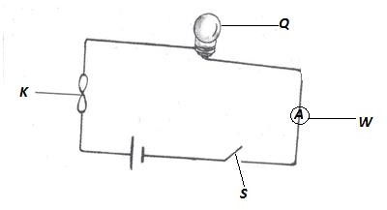

1. Name the parts marked S and W

S: ………………………………………………. W: ………………………………………………………

1. Give the function of part marked K in the circuit.

……………………………………………………………………………………………….………………………………………………………………

1. Name any two energy changes that take place in part Q when S is closed?

i) ……………………………………………………………………………………………………………………………………………………….

ii) ……………………………………………………………………………………………………………………………………………………….

1. How is part K similar to parts S in terms of function?

………………………………………………………………………………………………………………………………….…………………………….

1. What type of energy is stored in part Q?

…………………………………………………………………………………………………………………………..…………………………………..

1. Name any two forms of energy produced at Q when the circuit has been completed?

i) ………………………………………………………………………………………………………………………………………………………

ii) ……………………………………………………………………………………………………..……………………………………………….

1. Using arrows on the diagram, show the flow of current.
2. Name an example of static electricity in nature.

………………………………………………………………………………………………………………………………………………………………

1. What force enables the type named above to happen?

………………………………………………………………………………………………………………………………………………………………

1. Why the bulb of filament is made coiled?

………………………………………………………………………………………………………………………….…………………………………..

1. Name one device that converts electrical energy into mechanical energy?

……………………………………………………………………………………………………………………….……………………………………….

1. How does electricity generated at Jinja get to a consumer in Kasese town?

……………………………………………………………………………………………………………………………………………………………….

1. Why is it that most conducting wires are made of copper and aluminum not silver yet it is the best conductor?

………………………………………………………………………………………………………………………………………………………………

……………………………………………………………………………………………………………………………………………………………..

1. Why should electricity wires be properly insulated?

……………………………………………………………………………………………………………………………………………………………..

1. Define the term magnetism?

……………………………………………………………………………………………………………………………………………………………..

1. Give any two properties of a magnet?

i) ……………………………………………………………………………………………………………………………………………………

ii) ……………………………………………………………………………………………………………………………………………………

1. How can electromagnets be made stronger?

………………………………………………………………………………………………..………………………………………………………….

1. In what way is a magnet useful to a doctor in a hospital?

………………………………………………………………………………………………………….………………………………………………………

……………………………………………………………………………………………………….………………………………………………………….

1. State any three ways of demagnetizing a magnet?

i) ……………………………………………………………………………………………..…………………………………………………………..

ii) ………………………………………………………………………………………….……………………………………………………………….

iii) …………………………………………………………………………………………………………………………………………………………..

#### TOPIC: ENERGY RESOURCES

1. What is a resource?

……………………………………………………………………………………………………….……………………………………………………………

………………………………………………………………………………………………………..……………………………………………………………

1. Define the following terms;
   1. Energy

……………………………………………………………………………………………………………………………………………………………

……………………………………………………………………………………………………………………………………………………………

* 1. Energy resource

……………………………………………………………………………………..………………………………………………………………………

…………………………………………………………………………………..…………………………………………………………………………

1. Give any one reason why plants are regarded as energy resources?

………………………………………………………………………………………………………………………..……………………………………………

…………………………………………………………………………………………………………………………….…………………………………………

1. Identify two ways how man uses energy from the sun?

i) ……………………………………………………………………………………………………………………………………………………………

ii) ……………………………………………………………………………………………………………………….…………………………………..

1. Give any three forms of wood fuel used in production of heat and light.

i) …………………………………………………………………………………………………………………………..………………………………..

ii) …………………………………………………………………………………………………………………………………………………………..

iii) …………………………………………………………………………………………………………………………………………………………..

1. Write any three energy resources obtained from underground.

i) ……………………………………………………………………………………………………..………………………………………………….

ii) ……………………………………………………………………………………………………..…………………………………………………..

iii) …………………………………………………………………………………………………..…………………………………………………….

1. State the role of bacteria in a biogas production.

………………………………………………………………………………………………………………….………………………………………………

1. How do energy saving stoves help to conserve the environment?

……………………………………………………………………………………………………………..……………………………………………………

9. List down any four materials that can be used to generate biogas?

i) ………………………………………………………………………………………………...………………………………………………………….

ii) ……………………………………………………………………………………………..………………………………………………………………

iii) ……………………………………………………………………………………………..………………………………………………………………

iv) ……………………………………………………………………………………………………………………………………………………………..

1. List down any three fossil fuels obtained from underground?

i) ……………………………………………………………………………………………………..………………………………………………

ii) ……………………………………………………………………………………………………..………………………………………………

iii) ………………………………………………………………………………………………….…………………………………………………

1. How can deforestation affect production of hydroelectricity at the Owen falls dam?

………………………………………………………………………………………………………………………………………………………………

………………………………………………………………………………………………………………….…………………………………………..

1. State three ways how wind can be an energy resource?

i) …………………………………………………………………………………………………..…………………………………………………

ii) ………………………………………………………………………………………………..…………………………………………………….

iii) ……………………………………………………………………………………………….……………………………………………………….

1. Give the importance of solid residue after biogas production to a crop farmer?

………………………………………………………………………………………………….………………………………………………………………

1. Give one way of maintaining soil fertility.

…………………………………………………………………………………………..……………………………………………………………………..

1. How is carbon dioxide useful to man?

…………………………………………………………………………………………..………………………………………………………………………

1. Match items in list A with those in list B Thermal electricity uranium

Nuclear electricity fossil fuels

Hydroelectricity water

Static electricity friction

Hot springs

i) …………………………………………………………………………………………………………………….…………………………………….

ii) ……………………………………………………………………………………………………………………….………………………………….

iii) ………………………………………………………………………………………………………………………….……………………………….

iv) ………………………………………………………………………………………………………………………………..………………………….

1. Identify any four ways in which one can conserve resources from animals and plants

i) ……………………………………………………………………………………………………………………………………………………………

ii) ……………………………………………………………………………………………………………………………………………………………

iii) ……………………………………………………………………………………………………………………..……………………………………..

iv) …………………………………………………………………………………………………………………………………………………………….

#### TOPIC: MACHINES

1. What is a machine?

………………………………………………………………………………………………………………….…………………………………………………

…………………………………………………………………………………………………………….………………………………………………………

1. How do simple machine simplify work?

……………………………………………………………………………………………………………..……………………………………………………..

1. What is friction?

……………………………………………………………………………………………………………………………………………………………………

……………………………………………………………………………………………………………………………………………………………………

1. Name any three uses of friction?

i) ………………………………………………………………………………………………..………………………………………………………….

ii) ……………………………………………………………………………………………………………………………………………………………

iii) …………………………………………………………………………………………………………………………………………………………

1. Identify one way in which friction is of a disadvantage.

………………………………………………………………………………………….…………………………………………………………………………

1. Give two ways of increasing friction?

i) ……………………………………………………………………………..…………………………………………………………………………….

ii) ………………………………………………………………………….…………………………………………………………………………………

1. In which two ways is friction a nuisance force?

i) …………………………………………………………………………………………….…………………………………………………………….

ii) ………………………………………………………………………………………………..……………………………………………………………

1. Identify any two ways of reducing friction.

i) ………………………………………………………………………………..………………………………………………………………………..

ii) ……………………………………………………………………………………………………………………………………………………………

1. Why are objects like aero planes and boats streamlined?

…………………………………………………………………………………………………………………………………………………………………….

The diagram below shows a pair of scissors

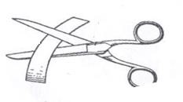

1. With the help of arrows, show the position of the effort, the fulcrum and the load.
2. To what class of levers do scissors belong?

………………………………………………………………………………………………………………………………………………………………….

1. To what group of simple machines does an axe belong?

……………………………………………………………………………………………………………………..………………………………………….

1. State the law of moments.

…………………………………………………………………………………………………………….………………………………………………………

…………………………………………………………………………………………………………………………………………………………………

1. Eric pushed a wheel barrow using a force of 25Newtons for a distance of 17metres.Calculate the work done by Eric.

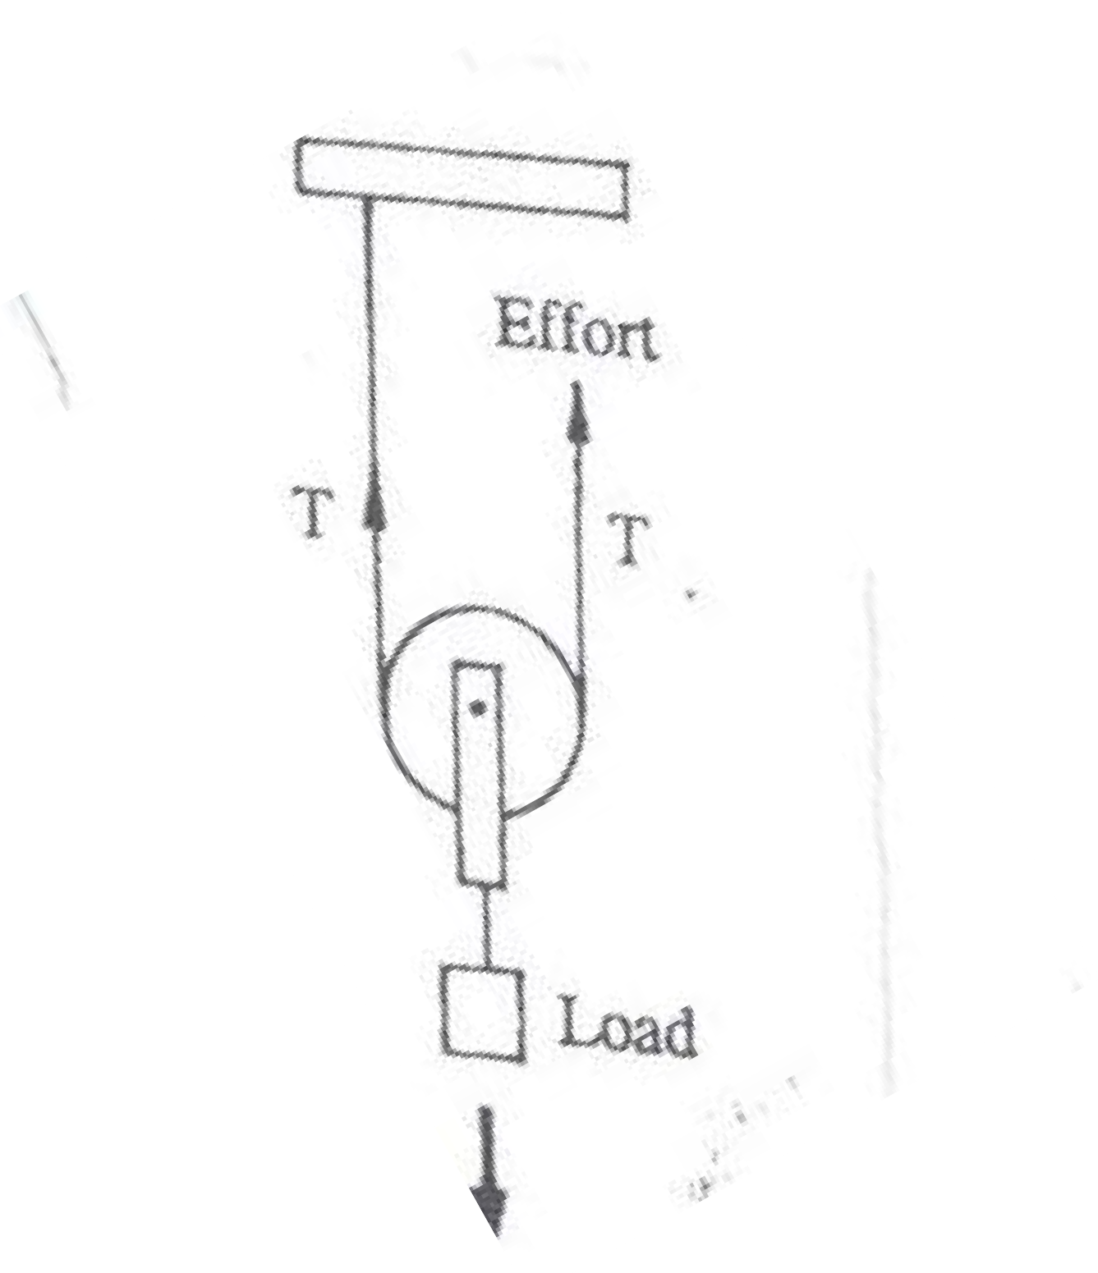Study the diagram below and answer the questions that follow

#### Y X

1. Name pulleys X and Y

X: ………………………………………………………………………………………………………………………………………………………..

Y: ……………………………………………………………………………………………………………..…………………………………………..

1. Which of the pulleys above needs less effort to raise a load of 60Newtons

…………………………………………………………………………………………………………………………………………………………………

1. Why should ball bearing be put in parts of a bicycle?

……………………………………………………………………………………………………………….………………………………………………

……………………………………………………………………………………………………………….………………………………………………

1. What is the function of an axe as a garden tool?

………………………………………………………………………………………………………………………………..………………………….

1. What would happen to a tool like an axe if left in moist area?

……………………………………………………………………………………………………………………………………….……………………

**The diagram below shows a simple machine used to lift a load of 100kf with an effort of 50kgf**

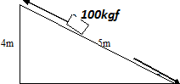

1. Name the simple machine shown above.

……………………………………………………………………………………..…………………………………………………………………………

1. What distance does
   1. Load move

…………………………………………………………………………..…………………………………………………………………………..

* 1. Effort move

…………………………………………………………………….………………………………………………………………………………….

1. What can you do to use less than 50kgf to pull the same load?

……………………………………………………………………………………………….…………………………………………………………………

1. Why are roads constructed with rough surfaces?

………………………………………………………………………………………………..……………………………………………………………….

1. Give any one use of a pulley at your school.

……………………………………………………………………………………………..………………………………………………………………….

#### TOPIC: EXCRETORY SYSTEM

1. Define the term excretion

……………………………………………………………………………………………….………………………………………………………………

……………………………………………………………………………………………………………………………………………………………..

1. State the main function of the kidney in the body.

………………………………………………………………………………………………………………………………………………………………

……………………………………………………………………………………………………………………………………………………………..

1. Where does filtration of blood to remove waste products take place in the kidney?

……………………………………………………………………………………………………………………………………………………………………

………………………………………………………………………………………………………..………………………………………………………..

1. List down any three components of urine.

i) …………………………………………………………………………………………………………………………………………………….

ii) ………………………………………………………………………………………………………………………..………………………….

iii) ………………………………………………………………………………………………………………………..…………………………

1. How is the medulla an important part of the kidney?

……………………………………………………………………………………………………………………………….……………………………

…………………………………………………………………………………………………………………………….……………………………..

1. State the role of the urinary bladder during excretion.

……………………………………………………………………………………………………………………………………………………………

…………………………………………………………………………………………………………………………….…………………………….

1. Name the water borne disease which attacks the urinary bladder.

…………………………………………………………………………………………………………………………………………………………….

1. Give anyone function of the human skin?

………………………………………………………………………………………………………………………………………………………………

1. Why do soles of the feet develop thick surfaces after doing heavy manual work?

……………………………………………………………………………………………………………………………………………………………..

1. State the two main layers of the human skin.

i) …………………………………………………………………………………………………………….………………………………………

ii) …………………………………………………………………………………………………………..…………………………………………

1. What pigment determines the skin colour?

………………………………………………………………………………………………………………..…………………………………………..

1. How is the kidney similar to the skin in terms of function?

………………………………………………………………………………………………………………………………………………………………

1. Give any two components of the sweat.

i) …………………………………………………………………………………………………………………………………………………………..…

ii) …………………………………………………………………………………………………………………………………………………..………….

1. Write down any three diseases which attack the skin.

i) ………………………………………………………………………………………………………………………………………………………………

ii) ………………………………………………………………………………………………………………………………………………………………

iii) ……………………………………………………………………………………………………………………………………….……………………..

1. State the blood vessels which transports digested food materials from the ileum to the liver?

………………………………………………………………………………………………………………………………………….………………………….

1. State the main function of the liver in the body.

…………………………………………………………………………………………………………………………………….………………………………

1. Why are the lungs considered to be both excretory and respiratory organs?

………………………………………………………………………………………………………………………………………………..……………………..

1. State the function of the cilia found in the nostrils of humans.

…………………………………………………………………………………………………………………………………………..……………………………

1. Give the value of the epiglottis during digestion.

……………………………………………………………………………………………………………………………………………………………………….

1. Why are we advised not to breathe through the mouth?

………………………………………………………………………………..…………………………………………………………………………………….

1. State the reason why the trachea is made of rings of cartilage.

………………………………………………………………………………………………………………………………………………………………………

1. By what process does gaseous exchange take place in the lungs?

…………………………………………………………………………………………………….………………………………………………………………..

1. What important process takes place in the lungs?

…………………………………………………………………………………………….…………………………………………………………………………

1. How are the air sacs adopted to their function?

………………………………………………………………………………………..………………………………………………………………………………

1. What happens to the diaphragm when we breathe in?

………………………………………………………………………………………….…………………………………………………………………………….

26. Name any two non-infectious diseases of the lungs?

i) ……………………………………………………………………………….………………………………………………………………………………

ii) ………………………………………………………………………..……………………………………………………………………………………..

1. Identify any two ways of maintaining the health of the excretory system.

i) ……………………………………………………………………………………………………………………………………………………………….

ii) ………………………………………………………………………….………………………………………………………………………………….

#### TOPIC: LIGHT

1. Name one natural source of light.

………………………………………………………………..…………………………………………………………………………………………………….

1. Give one difference between luminous and non-luminous object.

……………………………………………………………………………..……………………………………………………………………………………….

1. Identify the materials which;
   1. Do not allow any light reaching them to pass through them

…………………………………………………………………………………………………………………………………………………………….

* 1. Allows some light to pass through them

……………………………………………………………….…………………………………………………………………………………………..

1. Briefly explain how a solar eclipse is formed.

…………………………………………………………………………………………….……………………………………………………………………..

1. How is a shadow formed?

………………………………………………………………………..…………………………………………………………………………………………

1. State the difference between reflection and refraction?

…………………………………………………………………………………..………………………………………………………………………………

1. In the space provided below draw to show the difference between a converging and diverging beam of light?
2. What is the function of the sun in rainfall formation?

……………………………………………………………………………….………………………………………………………………………………….

1. Complete the diagram below correctly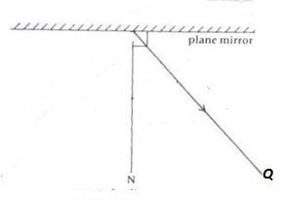
2. Name the ray marked **Q**

…………………………………………………………………………………………………………………………………………………………………..

1. State anyone law of reflection?

……………………………………………………………………………………..……………………………………………………………………….

1. How do images formed in pin-hole camera differ from those in a plane mirror?

……………………………………………………………………………………………………………………………………………………………….

1. Describe an experiment to show that light travels in a straight line.

……………………………………………………………………………………………………………………………………………………………….

1. Why aren’t able to be around corners?

…………………………………………………………………………………………………………….…………………………………………………

1. During a thunder storm, why is light seen before sound is heard?

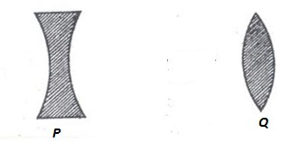………………………………………………………………………………………………………………………………………………………..……..

The diagram shows two different lenses, use them to answer the questions that follow

1. Name the lenses marked P and Q

**P** …………………………………………… **Q** ………………………………………………………..

1. What type of beam does lens **Q** produce when a parallel beam passes through it?

……………………………………………………………………………………………………………………..…………………………………………

1. The eye defect corrected by the lens marked by **P** and **Q**

**P** …………………………………………….. **Q** ………………………………………………………………

1. Name anyone eye disease caused by bacteria

……………………………………………………………………………………………………….………………………………………………………

1. What causes refraction of light?

……………………………………………………………………………………………….………………………………………………………………

1. What is dispersion of light?

………………………………………………………………………………………….……………………………………………………………………

1. Why does a green mug appear green?

…………………………………………………………………………………..…………………………………………………………………………

#### POPULATION AND HEALTH

1. Define the term human population?

………………………………………………………………………………………………………..………………………………………………………

1. Write down any four health concerns common in your area?

……………………………………………………………………………………………………..…………………………………………………………

1. Identify any three human activities that can lead to poor sanitation. (i)…………………………………………………………………………………………..…………………………………………………………………

(ii) ……………………………………………………………………………………………………..……………………………………………………

(iii) …………………………………………………………………………………………………..………………………………………………………

1. Give any two causes of sickness in a home.

(i) ………………………………………………………………………………………………..………………………………………………………….

(ii) ……………………………………………………………………………………………………………………………………………………………

1. Write two activities which can improve sanitation at home?

(i)……………………………………………………………………………………………………………………………………………………………

(ii)………………………………………………………………………………………………………..………………………………………………..

1. State three common anti-social behaviours in a school?

(i) ……………………………………………………………………………………………….…………………………………………………………

(ii) …………………………………………………………………………………………….………………………………………………………….

(iii) ………………………………………………………………………………………………………………………………………………………

1. Give any two natural changes which can result into insufficient food supply in a community?

(i) ……………………………………………………………………………………………………………………………………………………….

(ii) ……………………………………………………………………………………………………………………………………………………….

1. Identify any two ways how the government of Uganda has tried to improve on provision of clean water supply in your community?

(i) ………………………………………………………………………………………………….………………………………………………….

(ii) ………………………………………………………………………………………….………………………………….........................

1. What health problems can result from poor water supply in your area?

………………………………………………………………………………….………………………………………………………………………

…………………………………………………………………………………….……………………………………………………………………

………………………………………………………………………………….………………………………………………………………………

1. Outline two ways how we can promote health in a community?

(i) …………………………………………………………………………..…………………………………………………………………………

(ii) …………………………………………………………………………………………………………………………………………………….

1. Give any two values of budgeting in a family?

(i)…………………………………………………………………………………………………………..………………………………………………

(ii) …………………………………………………………………………………………………………………………………………………………….

1. State any two values of health surveys on area

(i)………………………………………………………………………………………………………….…………………………………………………

(ii)……………………………………………………………………………………………………………………………………………………………

1. Define the term demography as used in health education.

…………………………………………………………………………………………………………………………………………………………………

………………………………………………………………………………………………………………….………………………………………………

1. Identify anyone health danger of staying in overcrowded areas?

…………………………………………………………………………………………………………………………………………………………………

1. Give any two reasons why immunization of children is important?

(i)………………………………………………………………………………………………………………………………………………………………

(ii)………………………………………………………………………………………………….…………………………………………………………..

1. State the importance of a child health card to;
   1. Parent

…………………………………………………………………………………………….……………………………………………………………

………………………………………………………………………………………………………………………………………………………….

* 1. Doctor

…………………………………………………………………………………………………………………………………………………………

………………………………………………………………………………………..……………………………………………………………….

* 1. School health committee

……………………………………………………………………………………………….…………………………………………………………

………………………………………………………………………………………………………………………………………………………….

1. Why should an expectant mother be immunized with tetanus toxoid?

………………………………………………………………………………………………………..…………………………………………………………

……………………………………………………………………………………………………………………………………………………………………

1. How is a health centre important to people in the community?

……………………………………………………………………………………………………….……………………………………………………………

……………………………………………………………………………………………………………………………………………………………………

#### TOPIC: INTERDEPENDENCE OF LIVING THINGS

1. Define the term environment?

……………………………………………………………………………………………………………………………………………………………

……………………………………………………………………………………………………………………………………………………………

1. Give anyone living component of the environment?

……………………………………………………………………………………………………………………………………………………………

1. Define the term interdependence?

………………………………………………………………………………………………..……………………………………………………………

………………………………………………………………………………………………..……………………………………………………………

1. What is a resource?

……………………………………………………………………………………………….……………………………………………………………

……………………………………………………………………………………………….……………………………………………………………

1. Identify any three resources from the environment.

(i)…………………………………………………………………………………………………………..……………………………………………

(ii)……………………………………………………………………………………………………….……………………………………………..

(iii)……………………………………………………………………………………………………..……………………………………………….

1. Give any two ways in which living things depend on nonliving things?

7. (i)………………………………………………………………………………………………………………………………………………………….…

………………………………………………………………………………………………………………………………………………………………… (ii)…………………………………………………………………………………………………………………………….………………………………

……………………………………………………………………………………………………………………………….…………………………………

1. Identify two ways how animals depend on plants?

(i)………………………………………………………………………………………………………………………………………………………………

…………………………………………………………………………………………………………………………………………………………………… (ii)…………………………………………………………………………………………………..…………………………………………………………

……………………………………………………………………………………………………………………………………………………………………

9. Give three ways in which plants benefit from animals?

(i)………………………………………………………………………………………………………………………………………………………………

………………………………………………………………………………………………………………..………………………………………………… (ii)……………………………………………………………………………………………………….……………………………………………………

…………………………………………………………………………………………………………………………………………………………………… (iii)……………………………………………………………………………………………………………………………………………………………

……………………………………………………………………………………………………………….…………………………………………………

1. How do animals depend on each other?

…………………………………………………………………………………….…………………………………………………………………………

…………………………………………………………………………………………………………………………………………………….…………

1. How do plants depend on plants?

………………………………………………………………………………………………………………………………………………………………

………………………………………………………………………………………………………………………………………………………………

1. Study the organisms below and answer the questions that follow

Plant insects lizards hawks bacteria sun

1. What is the main role of the sun in the food chain?

………………………………………………………………………………..…………………………………………………………………………………

1. State one reason why plants are considered as producers?

……………………………………………………………………………………………………………………………………………………………………

……………………………………………………………………………………………………………………………………………………………………

1. What scientific term best describes lizards in the food chain above

…………………………………………………………………………………………………………………………………………………………………

1. What is agro- forestry?

………………………………………………………………………………………………………………….………………………………………………

1. State anyone reason why people plant trees in their compounds?

……………………………………………………………………………………………………………………………………………………………………

………………………………………………………………………………………………………..…………………………………………………………

1. State the importance of agro – forestry to the farmer?

…………………………………………………………………………………………………….……………………………………………………………

……………………………………………………………………………………………………….…………………………………………………………

1. Give any two qualities of good seeds or cuttings to be planted?

(i)……………………………………………………………………………………………..………………………………………………………………

(ii)……………………………………………………………………………………..……………………………………………………………………..

1. How does mulching improve soil fertility?

………………………………………………………………………………………………..…………………………………………………………………

……………………………………………………………………………………………………………………………………………………………………

1. How are sweet potatoes propagated?

……………………………………………………………………………………………………….…………………………………………………………

21. Give any two ways farmers can care for their trees in the garden?

(i)………………………………………………………………………………………………………………………………………………………………

(ii)……………………………………………………………………………………………….……………………………………………………………..

1. Why do some trees need pollarding?

……………………………………………………………………………………………………………………………………………………………………

…………………………………………………………………………………………………………………………………..………………………………

1. Identify any three methods of harvesting wood

(i)………………………………………………………………………………………………………………………………………………………………

(ii)……………………………………………………………………………………………………………………..………………………………………

(iii)………………………………………………………………………………………………………………….…………………………………………

1. Give two methods of planting crops? (i)……………………………………………………………………………………………………….………………………………………………………

(ii)……………………………………………………………………………………………………………..……………………………………………..

1. How do trees planted in a school garden prevent soil erosion?

………………………………………………………………………………………………………………….………………………………………………

………………………………………………………………………………………………………………………….………………………………………

1. Write down any three common trees planted for provision of hard wood?

(i) ……………………………………………………………………………………………………….…………………………………………………….

(ii) …………………………………………………………………………………………………………………………………………………………….

(iii) ……………………………………………………………………………………………………………………………………………………………

1. State the value of a nursery bed on a school farm?

…………………………………………………………………………………………………………………………………………………………………

1. List down any two effects of crop pests to our produce?

(i)…………………………………………………………………………………..…………………………………………………………………………

(ii) …………………………………………………………………………………………………………………………………………………………….

1. Match items in list **A** with those in list **B A B**

Cassava American boll worm

Banana mosaic

Ground nuts panama

Maize rosette disease

Streak disease